PRESS RELEASE FOR PUBLICATION

Leonberg, 23/06/2016

Sales start for the new interface module IQ box KNX:
more intelligent ventilation in the KNX environment – windows and components in dialogue
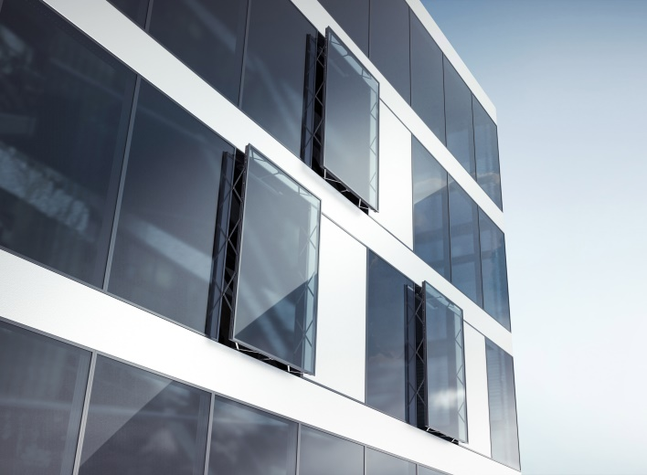

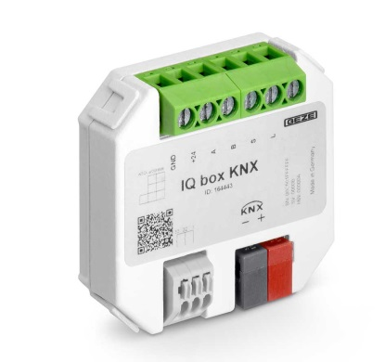

IQ box KNX: Window façade with GEZE IQ windowdrive drives, Photos: GEZE GmbH

With GEZE, the windows trade is becoming smart because access to the KNX world is easy with the IQ box KNX. For controlled, natural ventilation, the IQ box KNX makes it possible to integrate the intelligent window drives from the IQ windowdrives series into the KNX building bus. It creates new possibilities in building automation and therefore many advantages: more user convenience and security, a pleasanter and healthier indoor climate, as well as lower energy consumption.

With the interface module IQ box KNX, IQ windowdrive drives can be integrated into KNX building systems as direct bus participants. Window statuses (e.g. open/closed) can be displayed on a central visualisation panel, and controlled and checked from there. Not only can the automatic windows be opened and closed remotely from a central location, but they also enable direct communication with other components in the KNX building system, such as KNX push buttons and KNX sensors. In this way, all windows in a building can be closed at the push of a button. If a weather station reports rain or a certain wind speed, the window drives receive the signal to close from the IQ box KNX. With KNX air-quality sensors, the windows can be controlled depending on the CO₂ concentration, humidity or room ambient temperature. Through the precise control of the window drives, the KNX box facilitates controlled ventilation not only for a better indoor climate, but also for energy-saving potential.

The IQ box KNX offers additional security: in contrast to simple switch contacts, it uses the intelligence of the window drives and after performing a "command" reports the status of a window to the KNX building system or the building management system. Additional window information is also provided by the module, e.g. the precise opening width (as a percentage), any faults or, as "predictive maintenance", the number of opening and closing cycles.

For a whole office complex: comfort and energy efficiency
Even before the IQ box KNX officially went on sale GEZE had won an important order: as the first stage of the revitalisation of an office complex in central Frankfurt and its certification according to the latest environmental standards, over the next few months 400 out of a total of 2,500 bottom-hung windows will be automated with "F 1200 Electric" turn and tilt fitting systems from the IQ windowdrive series. The window drives are being incorporated into the existing KNX building system via IQ box KNX interface modules. For the building operator this makes building monitoring much more convenient, efficient and economical. The communication, e.g. between heating control and the intelligence of the window drives, provides a reduction of heating costs. Windows close if the heating or air-conditioning is activated in case of rain or wind. Natural ventilation then occurs automatically. The centralised control system also enables complete windows frontage or defined groups of windows to be controlled for night-time back cooling. If needs change, they can be adapted easily by the users by specifying new ventilation scenarios on a KNX visualisation panel.

